**VIEWS**

/* Customer_v – for each customer, indicate his or her name as well as the customer type (prospect, steady or premier) as well as the number of years that customer has been with us */

Create View customer_v as

SELECT privateIndividual.cFirstName AS 'First Name',

privateIndividual.cLastName AS 'Last Name',

'Prospective' AS 'Customer Type',

YEAR(CURDATE()) - YEAR(dateJoined) AS 'Number of Years'

FROM Customer

natural join privateIndividual

NATURAL JOIN prospectiveCustomer

UNION

SELECT privateIndividual.cFirstName AS 'First Name',

privateIndividual.cLastName AS 'Last Name',

'Steady Customer' AS 'Customer Type',

YEAR(CURDATE()) - YEAR(dateJoined) AS 'Number of Years'

FROM Customer

natural join privateIndividual

NATURAL JOIN steadyCustomer

UNION

SELECT privateIndividual.cFirstName AS 'First Name',

privateIndividual.cLastName AS 'Last Name',

'Premier Customer' AS 'Customer Type',

YEAR(CURDATE()) - YEAR(dateJoined) AS 'Number of Years'

FROM Customer

natural join privateIndividual

NATURAL JOIN premierCustomer;

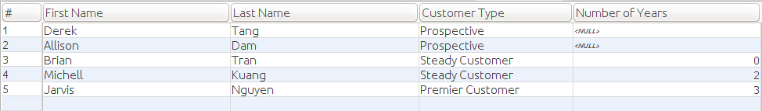

/* Customer_addresses_v – for each customer, indicate whether they are an individual or a

corporate account, and display all of the addresses that we are managing for that customer. */

Create View customer_address_v as

SELECT privateIndividual.cFirstName AS 'First Name',

privateIndividual.cLastName AS 'Last Name',

'Individual' AS 'Customer Type',

privateIndividual.mailingAddress AS 'Address'

FROM Customer

natural join privateIndividual

NATURAL JOIN prospectiveCustomer

UNION

SELECT privateIndividual.cFirstName AS 'First Name',

privateIndividual.cLastName AS 'Last Name',

'Individual' AS 'Customer Type',

privateIndividual.mailingAddress AS 'Address'

FROM Customer

natural join privateIndividual

NATURAL JOIN steadyCustomer

UNION

SELECT privateIndividual.cFirstName AS 'First Name',

privateIndividual.cLastName AS 'Last Name',

'Individual' AS 'Customer Type',

privateIndividual.mailingAddress AS 'Address'

FROM Customer

natural join privateIndividual

NATURAL JOIN premierCustomer

UNION

SELECT distinct corporateCustomer.corporationName AS 'First Name',

corporateCustomer.corporationName AS 'Last Name',

'Corporation' AS 'Customer Type',

corporateAddress.addressField as 'Address'

from Customer inner join corporateCustomer on Customer.customerID = corporateCustomer.customerID

inner join corporateAddress on Customer.customerID = corporateCustomer.customerID

group by corporateCustomer.corporationName, corporateAddress.addressField;

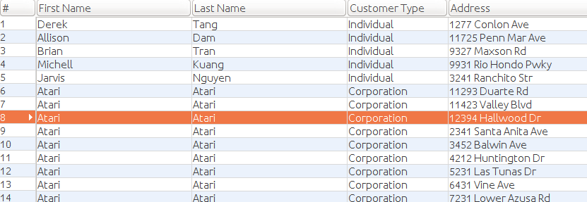

/* Mechanic_mentor_v – reports all of the mentor/mentee relationships at Dave’s, sorted by the

name of the mentor, then the name of the mentee. */

/* Premier_profits_v – On a year by year basis, show the premier customer’s outlay versus what they would have been charged for the services which they received had they merely been steady

Customers. */

create view premier_profits_v as

select privateIndividual.cFirstName as 'First Name',

privateIndividual.cLastName as 'Last Name',

premierCustomer.moneySpent as 'Premier',

premierCustomer.moneyIfSteady as 'If Steady'

from Customer natural join privateIndividual

natural join activeCustomer natural join premierCustomer;



/* Prospective_resurrection_v – List all of the prospective customers who have had three or more contacts, and for whom the most recent contact was more than a year ago. They might be ripe for another attempt. */

**Changed it to two more contacts\***

create view prospective_resurrection_v as

SELECT privateIndividual.cFirstName AS 'First Name',

privateIndividual.cLastName AS 'Last Name'

FROM Customer

NATURAL JOIN privateIndividual

NATURAL JOIN prospectiveCustomer

WHERE (DATE(CURDATE()) - DATE(prospectiveCustomer.lastContacted)) > 365

AND prospectiveCustomer.numContacts >= 2

GROUP BY cFirstName, cLastName;

